**Data Manipulation Language (DML) Commands in Oracle:**

DML stands for Data Manipulation Language. DML commands are basically used to INSERT, UPDATE, and DELETE data in a database table. That means DML statements affect the records in a table

Syntax1 :

In this syntax values for all the columns are given in the same sequence they are defined in the table

INSERT INTO tablename VALUES ( VALUE1 , VALUE2, VALUE3…..);

**Syntax2:** In this syntax we have specified the column names explicitly and we need to provide the values for the specified columns only. The missing columns will take “null” by default.

INSERT INTO tablename (REQUIRED COLUMN NAMES ) VALUES ( VALUE1, VALUE2…);

##### ****to insert NULLs into a table****

##### **syntax:**

##### **INSERT INTO tablename VALUES ( NULL , NULL , NULL) ;**

##### **INSERT INTO tablename ( column1, column2 , column3 ) VALUES ( NULL, NULL , NULL);**

##### ****to insert multiple rows into a table****

##### **there are 2 ways to perform this operation:**

1. &: to insert values to columns dynamically (we can change values)

##### **Syntax1(&): For all columns**

INSERT INTO tablename VALUES ( &col1, &col2 , &col3 );

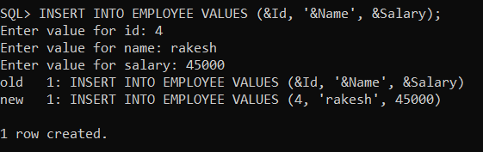

The / is used to re-execute the last executed SQL query in SQL Plus editor. Once you type the / button and press the enter key then again it will ask you to enter the Id, Name, and salary column values one by one

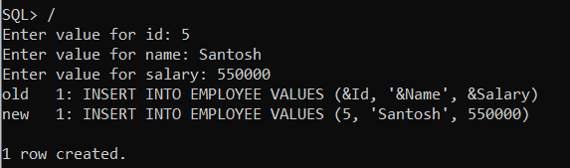

##### ****Syntax2(&): For required columns****

##### **INSERT INTO tablename ( col1 , col2 , col3 ) VALUES (&val1, &val2 , &val3 );**

##### 

1. &&: to insert fixed values to columns (we cannot change values). We can insert values to columns in a fixed manner. If we want to change a fixed value of a column then we should “exit” from the oracle database.